C:\Users\Munski\AppData\Local\Microsoft\Windows\Temporary Internet Files\Content.IE5\8987WDU4\MC900287374[1].wmf

Animals excrete water through feces

and urine.

Water is respired or evaporated from the bodies of animals.

Body water is the water content of an animal body; usually about 60% of an animal’s weight is water content.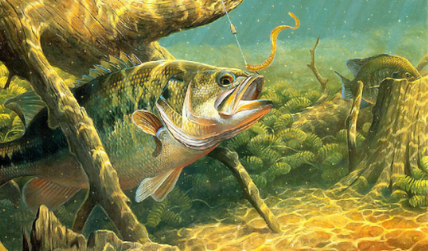Lake

Water is pulled by gravity to the lake.

Lake habitat is important to many plants and animals.

Water evaporates from the lake and goes to the clouds.

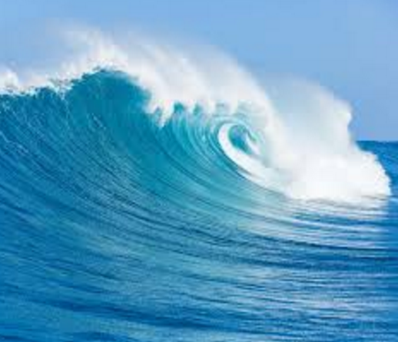

Ocean

Water is pulled by gravity to the ocean.

Ocean habitat is important to many plants and animals.

Water evaporates from the ocean and goes to the clouds.

C:\Users\Munski\AppData\Local\Microsoft\Windows\Temporary Internet Files\Content.IE5\5NQGRCJF\MC900231353[1].wmf

River

Water is pulled by gravity to the river.

River habitat is important to many plants and animals.

Water evaporates from the river and goes to the clouds.

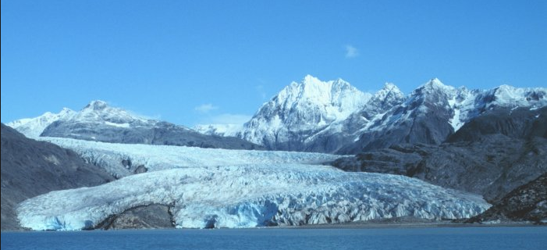

Glacier

Ice melts and water seeps into the ground.

Ice melts and flows in rivers, lakes, and oceans.

Ice melts to water, evaporates and goes into the clouds.

**C:\Users\Munski\AppData\Local\Microsoft\Windows\Temporary Internet Files\Content.IE5\8987WDU4\MC900437459[1].wmf**

Plants

Water is used by the plant and stored in plant cells.

Water travels up the roots of plants.

Water leaves the plant through the process of transpiration.

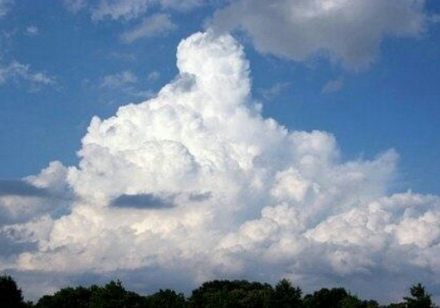

Clouds

Water condenses in the clouds and rain falls.

Water crystallizes in the clouds and snow falls.

Water freezes in the clouds and ice falls.

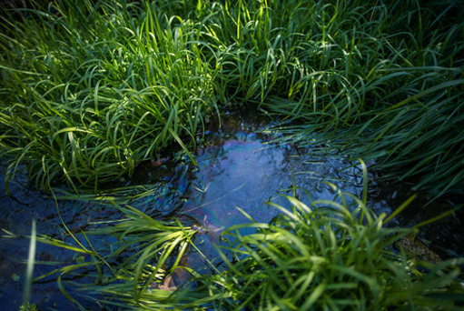

Groundwater

Water filters through the ground pulled by gravity to aquifers. An aquifer is an underground layer of water-retaining rock.

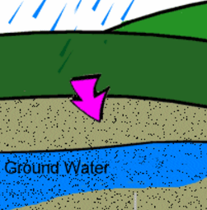

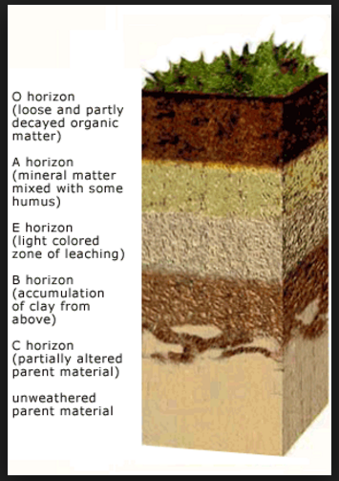

Soil soaks up as much water as it can hold.

Water runs off soil pulled by gravity.

Standing water forms puddles.

Standing water evaporates and goes into the clouds.